Weaponized Capital and the Green Transition: Realigning Global Investment Strategies in an Era of Geopolitical Fragmentation

Author: Abhijeet Kangane
Institute: Shri Ram College of Commerce (SRCC)
Contact: abhijeet666k@gmail.com
Batch: 2026
Submission for VITTA 2026: Call for Articles

Table of Contents

Abstract
In an era where geoeconomic fragmentation is reshaping global markets, capital allocation is undergoing a paradigm shift from efficiency-optimized globalization to security-optimized regionalization. This article explores the intersection of macroeconomic policy, geopolitics, and capital markets, focusing on how the "weaponization" of critical mineral supply chains distorts free-market dynamics and inflates the cost of the green transition. By analyzing recent IMF projections indicating a fragmentation cost of up to $307 billion annually, and IEA data highlighting highly concentrated mineral processing, the paper argues that industrial policies such as the US Inflation Reduction Act (IRA) represent a new "Geoeconomic Trilemma." While massive redundant capital expenditures are required for supply chain resilience, this geopolitical premium threatens emerging market sovereign debt and the overall timeline of global decarbonization.
Keywords: Geoeconomic Fragmentation, Green Capital Allocation, Critical Minerals, Industrial Policy, Sovereign Debt.

1. Introduction: The End of Frictionless Globalization
For the past three decades, global capital markets operated on a singular, undisputed axiom: capital flows to where it can be deployed most efficiently. This era of frictionless globalization fostered "just-in-time" supply chains and drove the cost of manufacturing down, lifting millions out of poverty and seemingly securing a deflationary economic environment. However, the cascading shocks of the early 2020s—from global pandemics to wars in Eastern Europe and the Middle East—have fundamentally fractured this consensus. We have entered a new era characterized by geoeconomic fragmentation, where geopolitical alignment supersedes pure economic efficiency in determining capital allocation.
Nowhere is this shift more pronounced than in the financing of the global green transition. The race to achieve net-zero emissions is fundamentally a race to secure and process critical minerals—lithium, cobalt, rare earth elements, and copper. As major powers recognize the strategic vulnerabilities inherent in monopolized supply chains, capital is being aggressively "weaponized" through tariffs, export controls, and massive state subsidies. The International Monetary Fund (IMF) estimates that geoeconomic fragmentation could impose an annual cost of between $213 billion and $307 billion on the global economy, adding up to 0.3 percentage points to global inflation (IMF, 2026). This article examines how the pursuit of supply chain security is distorting free-market investment, creating a new geopolitical premium on green capital, and threatening the sovereign debt stability of emerging markets.

2. The Geoeconomic Trilemma: Security, Efficiency, and Decarbonization
To understand the current macroeconomic environment, one must conceptualize the "Geoeconomic Trilemma." Policymakers are attempting to balance three competing objectives: maintaining free-market efficiency, ensuring national security through supply chain resilience, and achieving rapid decarbonization. In the current geopolitical climate, achieving all three simultaneously is mathematically and politically impossible.
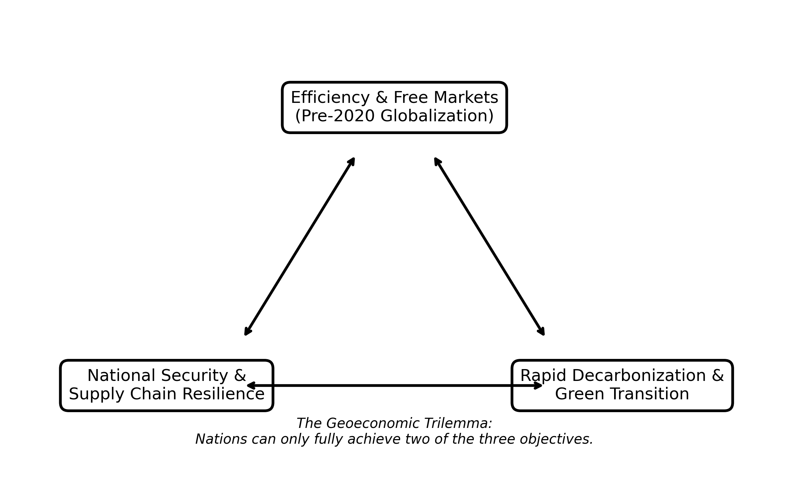
Figure 1: The Geoeconomic Trilemma (Original Framework constructed by Author)
When nations prioritize security and decarbonization—as seen with recent Western industrial policies—they must sacrifice efficiency. This sacrifice manifests as a massive requirement for redundant Capital Expenditures (CapEx). Instead of relying on a single, highly efficient global supplier, countries are building parallel, localized supply chains. This shift from "just-in-time" to "just-in-case" logistics requires trillions of dollars in new investments to mine, refine, and manufacture green technologies domestically or in allied nations ("friend-shoring"). This duplication of effort inherently drives up the aggregate cost of the green transition, a phenomenon increasingly termed "greenflation."

3. Industrial Policy and Market Distortion: The IRA and Beyond
The most glaring example of capital weaponization is the resurgence of aggressive industrial policy. The United States’ Inflation Reduction Act (IRA) of 2022 marked a watershed moment, deploying hundreds of billions of dollars in tax credits and subsidies specifically tied to domestic sourcing requirements. While lauded domestically as a triumph of climate legislation, internationally it acted as a giant vacuum, siphoning foreign direct investment (FDI) away from traditional allies and emerging markets.
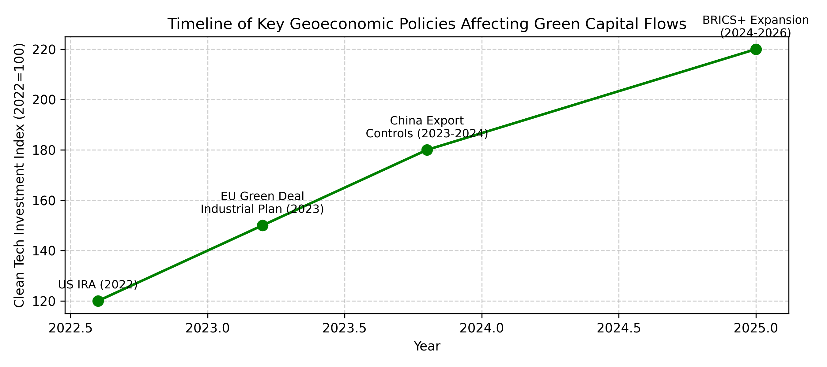
Figure 2: Timeline of Geoeconomic Industrial Policies and Clean Tech FDI Surges (Original compilation based on UNCTAD data)
The European Union was forced to respond with its Green Deal Industrial Plan to prevent corporate capital flight. This tit-for-tat subsidy race distorts the fundamental principles of corporate finance. Private capital is no longer flowing toward projects with the highest organic Return on Investment (ROI) based on technological superiority or resource abundance. Instead, capital is chasing the highest government subsidies. This state-directed capital allocation severely misprices risk and crowds out private investment in non-aligned developing nations, further widening the global climate finance gap.

4. The Critical Minerals Chokepoint and Emerging Market Debt
The physical reality of the green transition is entirely dependent on critical minerals. Currently, the supply chain for these minerals is dangerously concentrated. According to recent reports by the International Energy Agency (IEA), China processes approximately 90% of global rare earth elements, 100% of refined graphite, and 74% of lithium and cobalt (IEA, 2025). This midstream dominance provides unprecedented geopolitical leverage.
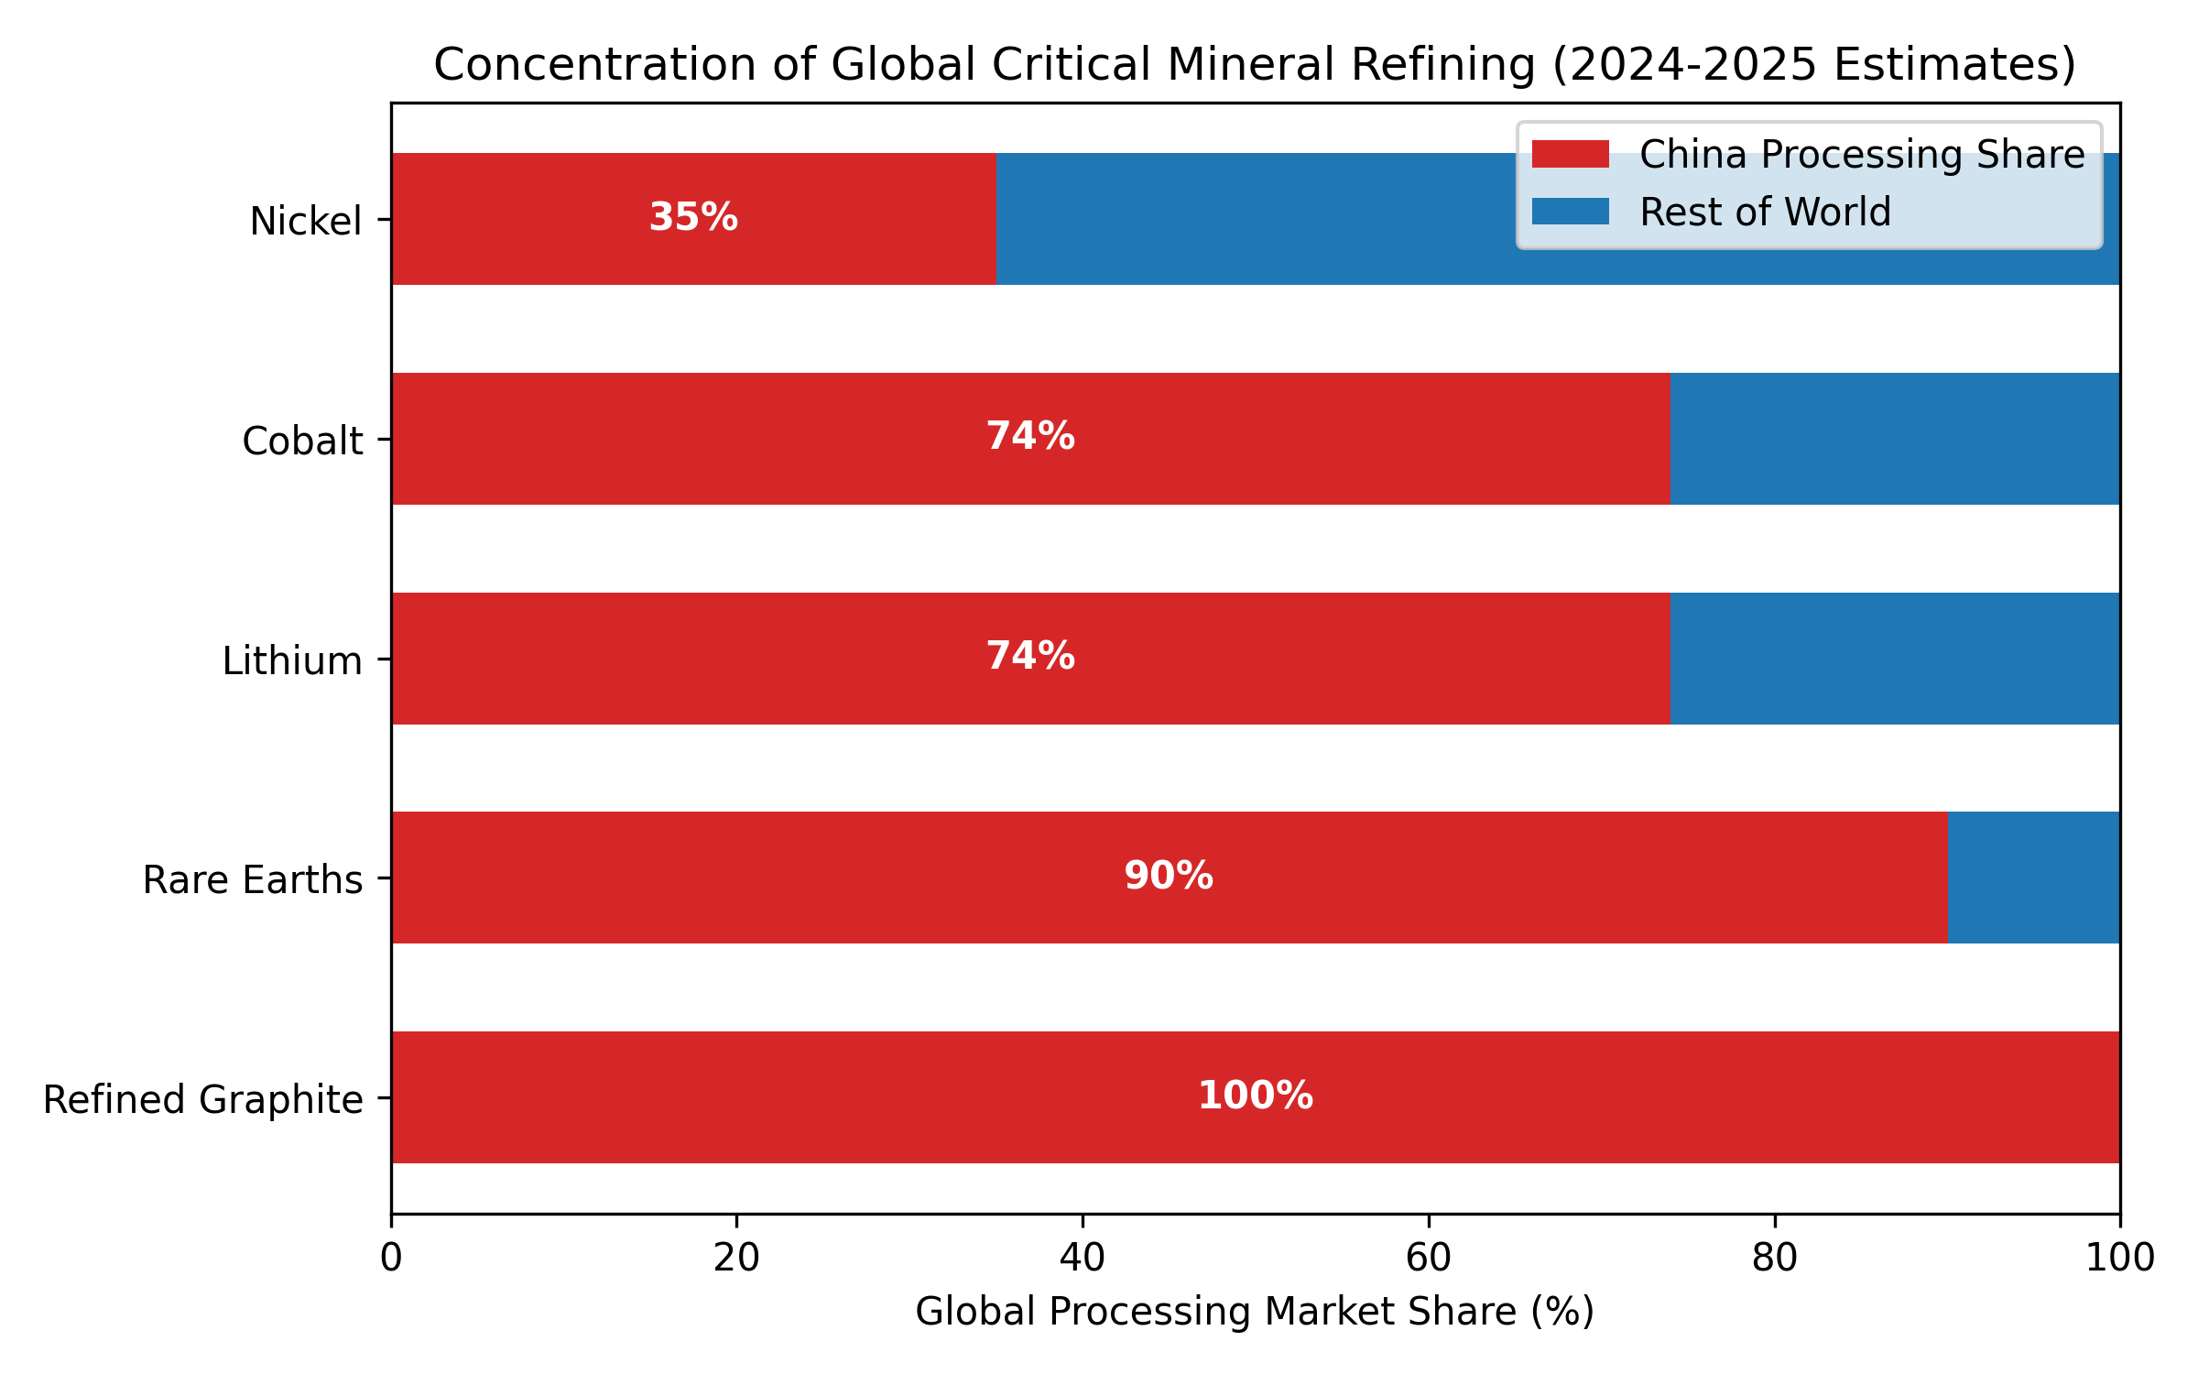
Figure 3: Concentration of Critical Minerals Processing (Adapted from IEA Global Critical Minerals Outlook 2025)
As Western nations scramble to secure independent supply lines, emerging markets in Africa and South America—where the unmined reserves are located—have become the new geopolitical battleground. However, this is a double-edged sword for these developing economies. On one hand, they possess the leverage to demand technology transfers and localized processing facilities. On the other hand, their sovereign debt profiles are becoming highly politicized. The IMF notes that emerging markets outside major geopolitical blocs face a significantly larger potential hit to GDP growth due to fragmentation. Sovereign debt restructuring is increasingly stalled by disagreements between traditional Western Paris Club creditors and new institutional lenders within the BRICS+ framework, trapping vulnerable economies in liquidity crises precisely when they need to invest in climate resilience.

5. Counterarguments: The Limits of Decoupling
Despite the prevailing narrative of fragmentation, absolute decoupling remains highly improbable. The global financial system and clean energy supply chains are so deeply integrated that severing them entirely would induce catastrophic economic depressions, a cost no rational political actor is willing to bear. Profit motives within private equity and multinational corporations will continually seek loopholes in geopolitical barriers. Furthermore, the rapid pace of technological innovation serves as a deflationary counterweight. For instance, the development of sodium-ion batteries or alternative electric motor chemistries that do not rely on rare earth elements could rapidly de-weaponize specific supply chains, reducing the geopolitical premium currently priced into capital markets.

6. Future Outlook and Investment Strategy
Looking toward the end of the decade, investment strategies must fundamentally incorporate geopolitical risk as a baseline metric, not a tail-risk anomaly. Asset managers will increasingly construct portfolios based on "geopolitical alpha"—identifying companies and sovereigns that successfully navigate or benefit from friend-shoring policies. Capital will flow preferentially to jurisdictions that offer regulatory certainty, robust domestic subsidy support, and secure access to raw materials. In corporate finance, the cost of capital will bifurcate; firms aligned with national security imperatives will enjoy subsidized, lower-cost financing, while those exposed to adversarial supply chains will face severe risk premiums.

7. Conclusion
The financialization of geopolitics has irrevocably altered the landscape of global investment. The green transition, once viewed as a universal collaborative effort, has been subordinated to the imperatives of national security and economic statecraft. While industrial policies and supply chain weaponization drive necessary investments in resilience, they simultaneously distort markets, inflate costs, and threaten the economic stability of non-aligned emerging nations. Navigating this fractured environment requires a sophisticated synthesis of macroeconomics and geopolitics, as the invisible hand of the free market is increasingly guided by the heavy hand of the state.

Author Declarations
Originality Statement: I, Abhijeet Kangane, hereby declare that this article, titled "Weaponized Capital and the Green Transition: Realigning Global Investment Strategies in an Era of Geopolitical Fragmentation," is my original work and has not been previously published elsewhere. The plagiarism level is strictly maintained below the 10% threshold as per the VITTA 2026 guidelines.
Image Credits: All figures generated specifically for this article. Figure 1 is an original conceptual framework. Figure 2 is an original compilation utilizing UNCTAD baseline data. Figure 3 is adapted directly from the IEA Global Critical Minerals Outlook.

References
International Monetary Fund (IMF). (2026). World Economic Outlook: Geoeconomic Fragmentation and the Global Economy. Washington, DC.
International Energy Agency (IEA). (2025). Global Critical Minerals Outlook 2025. Paris, France.
United Nations Conference on Trade and Development (UNCTAD). (2025). World Investment Report: FDI and the Green Transition. Geneva, Switzerland.
BlackRock Investment Institute. (2026). Global Outlook: Navigating Geopolitical Fragmentation in Capital Markets. New York, NY.

